Data Centers:
What do we need all this data for?
A Mathematical Analysis
by Manuel & Susan Luschas
Last edited: September 22nd, 2026

- Executive Summary
Is your phone too slow? Does your streaming movie have glitches or delay? Do you have to wait too long for artificial intelligence (AI) to give you an answer when you ask it for something? How many data centers do we really need for our everyday daily digital activities?
Data centers are being pushed all over the United States. Why? How will they make our lives better? What is the real reason for transmitting, storing, and processing all this data?
This white paper is an attempt to address all of these questions purely from a mathematical standpoint. The authors are uniquely positioned with backgrounds in electrical engineering and digital communication technology to make necessary assumptions and calculations to attempt to tackle this analysis.
Digital activities are calculated in Watts (W) of data center processing power consumption so they can be directly compared to the power consumption specifications of data centers that are being built across the United States of America (USA). The analysis is conducted with reference to the authors’ home state of South Dakota, as well as to the whole USA.
For the non-technical reader, here is the relationship between the power numbers cited in this paper:
1TW = 1,000GW = 1,000,000MW = 1,000,000,000kW = 1,000,000,000,000W (1)
Table 1 shows the calculation results of the amount of power consumed by data centers for various activities in the State of South Dakota and the USA.
The total current and predicted future power consumption of data centers in the State of South Dakota and the whole USA are summarized in Table 2.

Table 1: Summary of the amount of data center power consumption needed for various activities
Activities | South Dakota | USA
Daily Digital Activity (worst case scenario: video streaming 7 hours/day/person) | 16.2MW | 4.5GW
Citizens daily AI Use | 472kW | 132MW
Self Driving Cars Now | 0 | 43.4kW
Self Driving Cars If Everyone Had One | 8.6MW | 3GW
Crypto Currency Mining | 30MW | 10GW
Total Everyday Digital Activities | 55.3MW | 17.7GW

Table 2: Summary of current and predicted future data center power consumption
Total Data Center Power Consumption | South Dakota | USA
Now – most current available data | 32MW (2026) | 54GW (2024)
Predicted by 2030 | 1.29GW* | 148.2GW
Control Grid of a Digital Surveillance State (Utopia) | 9GW | 3TW
* Assumes only currently-known data center projects in South Dakota will be built.
Compare the “Total Everyday Digital Activities” power consumption number in the last row in Table 1 with the total data center power consumption numbers in the first two rows of Table 2 (“Now” and “Predicted by 2030”): Current data center processing capacity is enough for our everyday digital activities USA wide. South Dakota needs to add about 23MW in capacity to cover all activities listed in Table 1. Looking at the predicted capacity for 2030, there is a factor of 8 to 23 of overcapacity for plans to build new data centers in the USA and in South Dakota, respectively.
The calculation results in Tables 1 & 2 are based on current technology assumptions. The processing power needed to perform tasks is changing dramatically over time with advancements in chip technology and algorithmic efficiency. The authors expect the amount of data center power necessary to carry out these tasks to decrease over time.
The remainder of this paper details the assumptions and calculations behind the numbers in Tables 1 & 2. The Appendices further clarify several of the assumptions. They also include limited information on some related topics like data center placement near urban areas, claims of importance to national security, and keeping up with China’s advancements in technology.
- Table of Contents

1. Executive Summary 1
2. Table of Contents 3
3. Daily Digital Activity Calculations 4
4. Citizen’s Daily AI Use 5
4.1. Energy Consumption of AI Queries 5
4.2. What Kind of Queries? 5
4.3. How many Queries? 6
4.4. Adding it all up 6
5. Self Driving Cars 7
6. Bitcoin and Crypto Currency Mining 8
7. Total Data Center Consumption – Now and in the Future 9
8. Adding Up the Numbers – Do they make sense? 10
9. Digital Surveillance / Control Grid/ Utopia 12
9.1. Video surveillance 16 hours/day (8 hours/day of sleep) for every person 12
9.2. Facial recognition is needed once every 5 seconds for those 16 hours – e.g. Who is going in the ocean before the time swimming is allowed? 13
9.3. Language interpretation every 5 seconds – e.g. Did you use a curse word? Did you say something illegal? 13
9.4. Decision making – Turn off cars, impose fines, etc. 13
10. Conclusion 14
Appendix 1 – Data Center Power Breakdown 16
Appendix 2 – Other Insignificant Everyday Digital Data Sources 16
Appendix 3 – Data Centers are near Urban Areas 19
Appendix 4– National Security & Keeping Up With China 20
Biographies 21
Contact 22
Disclaimer 22
Copyright Notice 22
Citation 22
Acknowledgements 22
Sources 23

- Daily Digital Activity Calculations
According to DemandSage [1], as of May 2026 Americans spend an average of 7 hours per day on screens. Let’s assume that in the worst case each user is spending all of that screen time streaming videos. Activities like calling, texting, or browsing the internet all use considerably less data than a video stream. The IEA [2] has conducted an analysis in 2020 on the amount of energy needed by data centers for various types of video streaming. The worst case in their analysis is an energy consumption of 0.0139kWh per viewing hour for a video stream with 4k pixels [3]. With the increase in efficiency in computing over the last 6 years this number is lower now, but let’s use this as a worst case to calculate the energy consumption of delivering data for streaming 7 hours of video:
0.0139kWh per viewing hour * 7hours = 0.0973kWh (2)
South Dakota has roughly 1 million (M) people; the USA has roughly 350M people.
The calculation of the energy consumption of 7 hours of video streaming for every person in South Dakota as follows:
0.0973kWh per person * 1M people = 97.3MWh (3)
With the assumption that in the worst case the videos are all streamed over a 12 hour daytime period each day, the power that is needed for data processing is calculated:
97.3MWh / 12hours = 8.1 MW (4)
Appendix 1 details the assumption that data center overhead is approximately equal to the data processing power required. This means that the data center capacity that is actually needed is twice of the value in (4):
8.1 MW * 2 = 16.2MW (5)
16.2MW of data center power is needed for every South Dakotan to stream 7 hours of video per day.
The same analysis can be done for the whole USA. The energy consumption of video streaming for 7 hours per day is:
0.0973kWh per person * 350M people = 34.1GWh (6)
Assuming video is streamed over a 15 hour daytime period each day the power consumption for data processing is:
34.1GWh / 15hours = 2.27GW (7)
Again, as detailed in Appendix 1 the power consumption of (7) needs to be doubled to consider the data center overhead. This means that the data center capacity needed is:
2.27GW * 2 = 4.54GW (8)
4.5GW of data center power needed for every USA citizen to stream 7 hours of video per day.
- Citizen’s Daily AI Use
How much data center power is used every time someone makes an AI query? The answer depends on the complexity of the query and what specific AI bot is used.
There are two components to AI power consumption. During AI ‘training’ the model learns, often by trial and error, to recognize patterns from data samples that are given to the model. AI ‘inference’ refers to the use of the trained AI model to make predictions or draw conclusions.

  - Energy Consumption of AI Queries
According to techplus trends [4], AI energy consumption is:
0.3Wh per query in inference + 0.1Wh per query in training = 0.4Wh per query (9)
3 layer labs [5] gives a summary of Epoch AI’s and Google Gemini’s energy consumption:
- Short text query: about 0.24Wh to 0.34Wh
- Medium query (10,000 input tokens): about 2.5Wh
- Long query (100,000 input tokens): about 40Wh
- Image and video generation use much more than text, though exact figures vary widely
Analysis data summarized by felloai [6] has similar energy consumption numbers as stated in [5] above.
Nature [7] in 2025 published the chart in Figure 1, which is consistent with the energy consumption numbers in [5] and [6] as well. This data indicates that the energy consumed to perform a task varies by orders of magnitude depending on the complexity of the task and the AI model used.
  - What Kind of Queries?
Since the energy consumption depends heavily on what kind of queries people are making, the answer to the question of what queries to use for this analysis appears to be rapidly evolving. Some sources claim short text queries like ‘What is the weather’ dominate [8] [9]. Others claim that generative AI use is increasing, which indicates that long queries are increasing [10] [11].
For this analysis, we assume all queries are ‘medium’ queries with an energy consumption of 2.5Wh.
If anyone has more up-to-date data, please let us know and we will update our results!
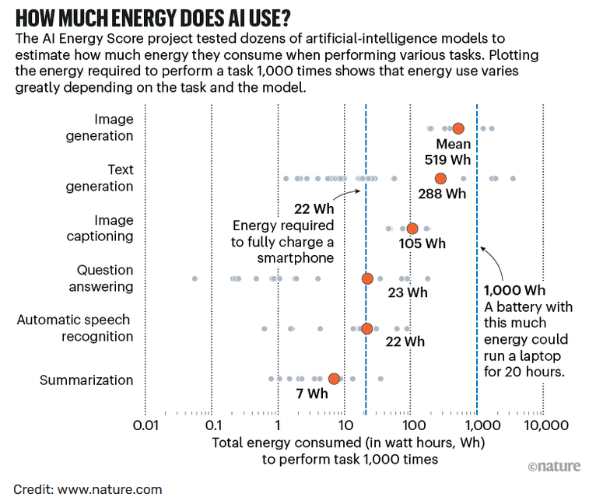
Figure 1: Chart of energy consumption for different AI tasks

  - How Many Queries?
How many AI queries per day do people make on average? At the February 2025 OpenAI DevDay, Sam Altman stated that ChatGPT receives 2.5 billion (B) ChatGPT prompts per day [12]. About 330M of those come from users in the USA. Month-over-month growth is estimated at 3.73%. That means the 330M queries per day figure from 2025 needs to be adjusted to 637M queries per day at the time of writing (August 2026) [13].
ChatGPT is estimated to have 80.49% of the worldwide AI chatbot market as of January 2026. This means that the total number of all AI queries from the USA is about 793M [13]. On average, this is about 2.3 queries per person per day in the USA.
  - Adding It All Up
Calculating the energy consumption of all AI queries per day in the USA gives:
793M queries * 2.5Wh per query = 1.98GWh (10)
Assuming all AI queries are made over a 15 hour daytime period leads to the total data center power consumption to process all American’s AI queries:
1.98GWh / 15hours = 132MW (11)
The authors are unable to find any AI query data specifically for South Dakota. The next best assumption is that Americans in all states submit an equal number of AI queries. With this assumption the calculation of the energy consumption of the AI queries of all South Dakotans yields:
793M queries * 1M SD people / 350M US people * 2.5Wh per query = 5.7MWh (12)
Assuming all AI queries are made over a 12 hour daytime period the data center power needed to process all South Dakotans AI queries is:
5.7MWh / 12 hours = 472kW (13)
- Self Driving Cars
Self driving cars have multiple cameras and radar sensors. They have to process that data and make decisions with low latency, meaning delay. Some of that data is processed immediately in the car and some of it is sent to a data center.
“A paper published by Dell EMC and Altran (Radtke, 2017) [14] reveals that just a single forward facing radar operating at 2800Mbits/s generates more than 1.26TB of data per hour, and a typical data collection car generates in excess of 30TB a day. Similarly, a two megapixel camera (24 bits per pixel) operating at 30 frames per second generates 1440Mbits of data every second, so a five camera setup can generate in excess of 24TB per day [15].”
According to the Automotive Edge Computing Consortium (AECC)’s February 2026 White Paper [16]: “About 90% of that data will be processed in the car. About 9% of that data will be processed at the ‘edge’ [17], meaning at a local data center closest to the vehicles on the road. About 1% of that data will be sent to a centralized data center, aka the ‘cloud’ [18].”
The amount of power needed to process all of that data is changing dramatically over time with increases in processing power and advanced in chip technology and algorithmic efficiency [19] [20] [21] [22].
The best estimate found was from a 2023 MIT paper [23] that states that a self-driving car computer consumes about 840W. If 10% of the data collected by the car is processed in a data center, that is about 93W of data center processing power consumption. According to the 2024 AAA American Driving Survey [24], the average American spends 60 minutes driving every day. This means each self-driving car needs about 93Wh of data center processing power per day.
As of Q2 2026, there are 3,500 fully autonomous self-driving cars on the road in the US [25]. That means the result of the calculation of required data center processing power consumption per day for all self-driving cars today is:
93Wh per car * 3,500 cars = 325kWh (14)
Assuming that cars are driving over a 15 hour period every day and that data centers will need a 2x overhead as described in Appendix 1, the data processing power required for all self-driving cars in the US today is:
325kWh / 15hours * 2 = 43.4kW (15)
According to Consumer Affairs [26], there are over 242M licensed drivers in the USA. What if moving forward all of them have self-driving vehicles? The amount of necessary data center processing power needed if everyone had a self-driving car can be calculated as:
93Wh per car * 242M cars / 15hours * 2 = 3GW (16)
The authors are unaware of any self-driving cars in South Dakota at the time of writing. If in the future, all South Dakotans got a self-driving car that would require data center processing power on the order of:
3GW * 1M South Dakotans / 350M Americans = 8.6MW (17)
- Bitcoin and Crypto Currency Mining
More than 95% of all Bitcoin that will ever exist is now in circulation. The current supply is around 20M Bitcoin, and there is a maximum supply of 21M Bitcoins. (Side note: Institutional investor Blackrock has admitted that there is ‘no guarantee’ that Bitcoin will be limited to 21M in supply [27].) This means there is about 1M Bitcoin left to be mined, which is expected to take about 114 years [28].
The details of how much power it takes to mine Bitcoin vary over time, primarily with mining hardware efficiency improvements, the price of Bitcoin, how many miners there are, and the price of electricity [29] [30]. The difficulty of mining Bitcoin automatically adjusts every two weeks. If lots of new miners join and Bitcoin are mined more quickly, the difficulty rises to slow things back down. Bitcoin miners can also drop offline due to unprofitability, regulatory crackdowns, or loss of power due to natural disasters. In this case, Bitcoin adjusts to become easier to mine. This means the same hardware that takes 9 years to mine 1 Bitcoin today could take 11 years if difficulty rises or 7 years if difficulty falls [31].
Thus, it is very hard to predict how much power will be needed to mine the last 1M Bitcoin. It is also unclear if the Bitcoin limit will increase, and at that point, whether another crypto will then dominate the crypto power consumption landscape.
The US Energy Information Administration (EIA) estimated electricity consumption from crypto currency mining operations in 2024 [30]. They identified 137 facilities and were able to trace the maximum electricity usage of 101 of those facilities. They estimate the usage of these 101 facilities to be 10.3GW. Comparing this amount to the average annual power demand of about 450GW in all of the United States, the crypto currency mining represents about 2.3% of total US electrical power demand.
If South Dakota is to have a fair share of crypto mining, it should result in data center power consumption for crypto currency mining in South Dakota of:
10.3GW * 1M South Dakotans / 350M Americans = 29MW (18)
Big Watt Digital has a 30MW crypto currency mining facility in Sally Buttes, SD [33]. Interestingly, this is close to the above calculated ‘fair share’ number. The Big Watt Digital crypto currency mining facility is planning to expand to 300MW in the future. This is the only South Dakota crypto currency mining facility that the authors are aware of at this time.
- Total Data Center Consumption – Now and in the Future
Lawrence Berkeley National Laboratory (LBNL)’s Data Center Energy Usage Report [34] has calculated and estimated the ‘Total US data center electricity use from 2017 through 2030’. Their estimates DO NOT include crypto currency mining. The estimates are for nameplate capacity – the IT hardware load they are designed to serve, as opposed to the grid interconnection capacity. Figure 2 shows the results of their calculations:
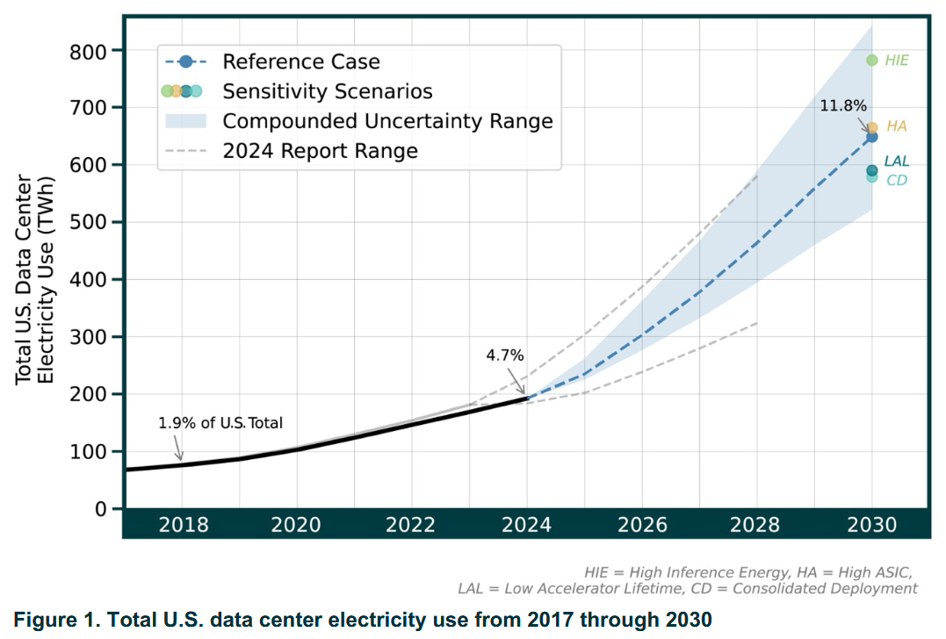
Figure 2: Total US data center electricity use from 2017 through 2030
The total data center energy consumption was 192TWh for the year 2024. These authors also use a factor of 2 to convert between grid interconnection capacity and nameplate capacity [35]. Assuming all the data centers are operating 24/7 at full capacity, the total installed data center power consumption in 2024 was:
192TWh per year * 1year / 365days * 1day / 24hours * 2 = 43.8GW (19)
The 2030 yearly reference case estimate for energy consumption of all installed data centers from Figure 2 is 649TWh. Repeating the calculation above yields the total estimated installed data center power consumption in 2030:
649 TWh per year * 1year / 365days * 1day / 24hours * 2 = 148.2GW (20)
The authors would like to note that this LBNL study is from June 2026 with 2025 updates. The current rapid evolution of industry technologies along with the political and economic push for data centers creates the large variation in future predictions. For example, [36] indicates that the US currently has 23.5GW of installed data center power just for AI facilities alone, with 43.6GW expected to be online in the next few years.
Table 3 gives an overview of the currently operating and proposed data centers with their respective power consumptions in South Dakota.
Table 3: List of data centers on South Dakota
Data Center | Power | Location | Status
Big Watt Digital (Crypto Currency Mining) [33] | 30MW (planned expansion to 300MW) | Sally Buttes, SD | Operating
TierPoint [37] | 2MW | Sioux Falls East, SD | Operating
TierPoint [37] | 1MW | Sioux Falls West, SD | Operating
Sequitor Edge [38] | 2MW | Rapid City, SD | Proposed
Leola [39] | 50MW | Leola, SD | Proposed
Applied Digital [40] | 430MW | Toronto, SD | Proposed
Gemini [38] | 500MW | Sioux Falls, SD | Proposed
Total Operating | 33MW | SD | Operating
Total Proposed | 1,252MW | SD | Proposed

- Adding Up the Numbers – Do they make sense?
Table 1 summarizes the total data center power consumption in South Dakota and in the US that was calculated in the previous sections. Table 2 compares these numbers to the total power consumption of installed data center today and those predicted to be installed in the future.
Table 1 (repeat): Summary of the amount of data center power consumption needed for various activities
Activities | South Dakota | USA
Daily Digital Activity (worst case scenario: video streaming 7 hours/day/person) | 16.2MW | 4.5GW
Citizens daily AI Use | 472kW | 132MW
Self Driving Cars Now | 0 | 43.4kW
Self Driving Cars If Everyone Had One | 8.6MW | 3GW
Crypto Currency Mining | 30MW | 10GW
Total Everyday Digital Activities | 55.3MW | 17.7GW

Table 2 (repeat): Summary of current and predicted future data center power consumption
Total Data Center Power Consumption | South Dakota | USA
Now – most current available data | 32MW (2026) | 54GW (2024)
Predicted by 2030 | 1.285GW* | 148.2GW
Control Grid of a Digital Surveillance State (Utopia) | 9GW | 3TW
* Assumes only currently-known data center projects in South Dakota will be built.
Currently, the USA already has enough data center power (54GW) for everyone to stream video 7 hours per day, have 2.2 medium-length AI queries per day, have a self driving car, and mine crypto currency at current power consumption levels (17.7GW). This is already a factor of 3 more data center power than the USA would need for current and future digital activities.
In 2030, the USA is predicted to have 148.2GW of data center power consumption for a need of 17.7GW. This is more than a factor of 8 times more power than citizens would need. Why is so much extra power needed? What is all this power for?
South Dakota needs an additional 23MW of data center power compared to what is available now if everyone is going to have a self-driving car and stream 7 hours of video per day. However, in 2030, South Dakota will have 23 times more data center power than citizens need for their everyday activities. Why is so much extra power needed? What is all this power for?

- Digital Surveillance / Control Grid/ Utopia
What is all this data center capacity needed for, if not for our daily digital activities? Could it be necessary for surveillance and control, similar to the Chinese social credit system?
Let’s consider a world like ‘Utopia,’ as depicted in this 15 minute movie [41]. What is the data center power that would be needed to run a society like Utopia?
To run Utopia, let’s make some assumptions about the data involved:
- Video streaming 16 hours per day (8 hours per day of sleep) for every person.
- Facial recognition needed once every 5 seconds for those 16 hours – e.g. Who is going in the ocean before the time when swimming is allowed?
- Language interpretation every 5 seconds – e.g. Did you use a curse word? Did you say something illegal?
- Decision making – e.g. Turn off cars, impose fines, etc.
The authors have been unable to find solid data on power needed specifically to recognize faces or interpret language. As summarized by a recent MIT Technology Review article: “In reality, the type and size of the model, the type of output you’re generating, and countless variables beyond your control—like which energy grid is connected to the data center your request is sent to and what time of day it’s processed—can make one query thousands of times more energy-intensive and emissions-producing than another. And when you query most AI models, … much of what happens after your question is routed to a data center remains a secret. Factors like which data center in the world processes your request, how much energy it takes to do so, and how carbon-intensive the energy sources used are tend to be knowable only to the companies that run the models…The key details are held closely by the companies that make them, guarded because they’re viewed as trade secrets (and also possibly because they might result in bad PR). These companies face few incentives to release this information, and so far they have not [42].”
Going through the components in calculating Utopia power, we will have to make more assumptions. Let’s tackle them one-by-one:
  - Video surveillance 16 hours/day (8 hours/day of sleep) for every person
Going back to the Daily Digital Activities (Section 3), let’s assume the same 0.0139kWh per viewing hour for a video stream with 4k pixels [3]. The video needs to be streamed for 16 hours per day over a 16 hour period. Calculating the data center power consumption per person per day yields:
0.0139kWh per viewing hour * 16 hours / 16 hour period = 0.0139kW (21)
The data center processing power consumption needed for South Dakota is calculated according to:
0.0139kW per person * 1M people = 13.9MW (22)
Appendix 1 details the assumption that data center overhead is approximately equal to the data processing power. This means that the actual data center power consumption to monitor every South Dakotan is:
13.9MW * 2 = 27.8MW (23)
The same can be done for the whole USA. The data center power consumption to monitor every USA resident is calculated as:
0.0139kW per person * 350M people * 2 = 9.7GW (24)
  - Facial recognition is needed once every 5 seconds for those 16 hours – e.g. Who is going in the ocean before the time swimming is allowed?
Going back to the above Citizens Daily AI Use (Section 4), there are multiple numbers to consider. The speech recognition task in Figure 1 is labeled as consuming 22Wh depending on the model and the exact task. However, Figure 1 also shows that number could vary by a factor of 3 in either direction. Generally once the facial model is trained, the authors think it will be more like a medium inference problem, indicating a number closer to 2.5Wh per instance. Calculating the data center processing power consumption that is needed for facial recognition every 5 seconds over a waking time of 16 hours per person per day gives:
2.5Wh / 5seconds * 3600seconds / 1 hour * 16hours / 16hours = 1.8kW (25)
The total data center processing power consumption needed for facial recognition of every South Dakotan is calculated according to:
1.8kW per person * 1M people * 2 = 3.6GW (26)
Again, the same can be done for the whole US. The data center power consumption for facial recognition of every US resident is calculated by:
1.8kW per person * 350M people * 2 = 1.2TW (27)

  - Language interpretation every 5 seconds – e.g. Did you use a curse word? Did you say something illegal?
The authors estimate that the power consumption for language recognition and interpretation should be similar to that calculated in section 9.2 for facial recognition.
  - Decision making – Turn off cars, impose fines, etc.
Let’s assume the decisions necessary to control behavior occur once every 10 seconds. Let’s also assume that comparing the images and speech to the list of rules is a ‘medium query’ using 2.5Wh/instance according to the list from the Citizens Daily AI Use (Section 4). The calculation to find the necessary data processing power consumption for behavioral control of one person every 10 seconds over 16 waking hours each day is:

2.5Wh / 10seconds * 3600seconds / 1hour * 16hours / 16hours = 0.9kW (28)
The total data center processing power consumption needed for behavioral control of every South Dakotan is calculated according to:
0.9kW per person * 1M people * 2 = 1.8GW (29)
Again, the same can be done for the whole US. The data center power consumption for behavioral control of every US resident is calculated by:
0.9kW per person * 350M people * 2 = 630GTW (30)
Table 4 summarizes the data center processing power consumption calculated for Utopia.
Table 4: Data center processing power consumption of Utopia
Activities | South Dakota | USA
Video Surveillance | 27.8MW | 9.7GW
Facial Recognition | 3.6GW | 1.2TW
Speech Recognition | 3.6GW | 1.2TW
Decision Making & Control | 1.8GW | 630GW
Total | 9GW | 3TW

The authors would like to reiterate that the AI computation numbers are not well known due to trade secrets in the industry and lack of public data. Furthermore, AI computation energy consumption is rapidly evolving with increases in processing power and advances in chip technology and algorithmic efficiency [5] [7] [42].
- Conclusion
Table 1 summarizes all the Data Center power consumption numbers calculated in the previous sections. Compare the “Total Everyday Digital Activities” power consumption number in the last row in Table 1 with the total data center power consumption numbers in the first two rows of Table 2 (“Now” and “Predicted by 2030”): Current data center processing capacity is enough for our everyday digital activities US wide. South Dakota needs to add about 23MW in capacity to cover all activities listed in Table 1. Looking at the predicted capacity for 2030, there is a factor of 8 to 23 of overcapacity for plans to build new data centers in the US and in South Dakota, respectively.
However, the current data center processing capacity is not enough to implement a surveillance state and control grid. Estimates of planned, future data center capacity show that it will also be not sufficient. However, as AI computation energy usage decreases over time with technology improvements, the authors expect the data center power requirements for the digital surveillance and control grid to decrease as well. These numbers could match up with the data center compute power consumption in the future. Appendix 3 offers another piece of evidence that data centers might be built for this goal – a chart of data centers that are located near urban areas.
It is unclear to the authors what else this overcapacity of data center compute power could be used for.
If you have any ideas that are not considered in this paper, please contact us!
Table 1 (repeat): Summary of the amount of data center power consumption needed for various activities
Activities | South Dakota | USA
Daily Digital Activity (worst case scenario: video streaming 7 hours/day/person) | 16.2MW | 4.5GW
Citizens daily AI Use | 472kW | 132MW
Self Driving Cars Now | 0 | 43.4kW
Self Driving Cars If Everyone Had One | 8.6MW | 3GW
Crypto Currency Mining | 30MW | 10GW
Total Everyday Digital Activities | 55.3MW | 17.7GW

Table 2 (repeat): Summary of current and predicted future data center power consumption
Total Data Center Power Consumption | South Dakota | USA
Now – most current available data | 32MW (2026) | 54GW (2024)
Predicted by 2030 | 1.285GW* | 148.2GW
Control Grid of a Digital Surveillance State (Utopia) | 9GW | 3TW
* Assumes only currently-known data center projects in South Dakota will be built.

Appendix 1 – Data Center Power Breakdown
Roughly one-half or greater of the electric power demand of data centers stems directly from the operation of electronic IT equipment. Much of the rest is for cooling. The core hardware components of a data center include compute servers, which contain computing chips (e.g. central processing units [CPUs] and graphics processing units [GPUs]), memory chips, data storage drives, and network routers and switches [43].
The power consumption of cooling systems can vary widely. For example, chilled water systems consume about 70% of the data center’s processing power, air cooling consumes about 100%, and cold climate cooling consumes about 20-40%. These power numbers are in addition to the data center’s power consumption for data processing. Estimates for Universal Power Supply (UPS) overhead have been made at 5% of data center processing power. Lighting comes in at 0.5% of data center processing power [44].
This white paper will assume a 50-50 split between data processing power and total ‘overhead’ power. This is consistent with the information in Figure 3:
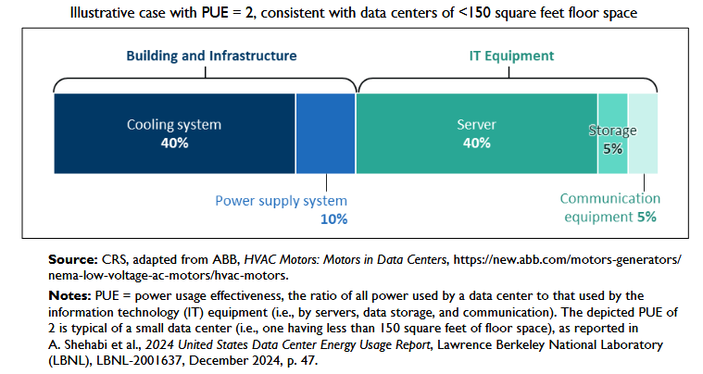
Figure 3: Notional Power Draws of IT Equipment and Infrastructure

Appendix 2 – Other Insignificant Everyday Digital Data Sources
What about hospitals that need to store data? What about farm equipment that records harvest data? What about banks that make digital transactions? This appendix calculates the nitty-gritty details of other sources of data that might be used productively in society. Many of these applications have their own servers and computers in their local facility. They simply don’t have enough data or compute power needs to utilize a data center.
These applications were not included in the main sections of the paper because they are insignificant amounts of data relative to the applications (video streaming, AI, crypto currency, etc) analyzed in the main paper. Still, we go through them in detail here to prove the point. The authors are open to adding other applications, feel free to contact us with things you would like to see included.
Farm Equipment Data
Are data centers needed to record farm equipment data, like crop yield, location, and machine parameters? The authors report the cloud data file sizes generated on their 110 acre grain row crop farm in Table 5.
Table 5: Farm equipment data file sizes
Equipment Pass | File Size
Planting | 13MB
Weeding (single pass) | 6.4MB
Combining | 18.8MB
Total | 38.2MB

The US had 248M row crop acres in 2025 [46]. Extrapolating the total data file size generated for the 110 acre row crop farm to the US wide farmed area is:
38.2MB / 110acres * 248M acres = 86.1TB (31)
Assuming all this farm data is taken over a 180 day (about 6 months) growing season yields the amount of data produced per in the US:
86.1TB / 180days = 478.5GB/day (32)
A single HD movie is about 3GB of data. That means that all the farm equipment data in the US is the equivalent of watching 159 movies per day. At 3 hours per movie, that’s about 478 hours of video streaming per day. Using the Daily Digital Activities (Section 3) again the energy consumption is calculated as:
0.0139kWh per hour * 478 hours = 6.6kWh (33)
Assuming this data is sent to data centers over a 12 hour period and including the 2x overhead factor the calculation of the necessary data center processing power is:
6.6kWh / 12hours * 2 = 1.1kW (34)

Hospital Medical Records
The WEF stated in 2019 that the world’s hospitals produce 50 petabytes (50*10^15) of data per year [47]. The US has about 12% of the world’s hospitals [48]. That means the amount of data generated by US hospitals per day is:
50petabytes * 12% of hospitals * 1 year/365 days = 16TB (35)
A HD movie is about 3GB. This is the equivalent of about 5,479 movies streamed per day. Using the numbers from Daily Digital Activities (Section 4), the calculation to derive the energy consumption to process this data is:
5479 movies * 3hours / movie * 0.0139kWh / movie viewing hour = 228.5kWh (36)
If this data is generated during a 12 hour period the total data center power consumption, including the 2x overhead factor for processing of all US hospital medical records is:
228.5kWh / 12hours * 2 = 38.1kW (37)
This data is from 2019, and one would expect the data to be larger in 2026. However, it would have to be a factor of 25,000 more to be on the order of magnitude of other digital activity sources considered in this paper.
If anyone does have more recent data, please let us know!
Summary
Table 6 shows a summary of the calculated data center power consumption numbers related to farm equipment and hospital medical records. Compared to other activities listed in the table, the data generated and processed by farming and hospitals are insignificant.
Table 6: Data center power consumption needed for various activities
Activities | South Dakota | USA
Daily Digital Activity (worst case scenario: video streaming 7 hours/day/person) | 16.2MW | 4.5GW
Citizens daily AI Use | 472kW | 132MW
Self Driving Cars Now | 0 | 43.4kW
Self Driving Cars If Everyone Had One | 8.6MW | 3GW
Crypto Currency Mining | 30MW | 10GW
Farm Tractor Data (2026) | 3W | 1.1kW
Hospital Medical Records (2019) | 109W | 38.1kW

Appendix 3 – Data Centers are near Urban Areas
The IEA created the plot shown in Figure 4 depicting how close various industrial facilities are to urban areas [49].
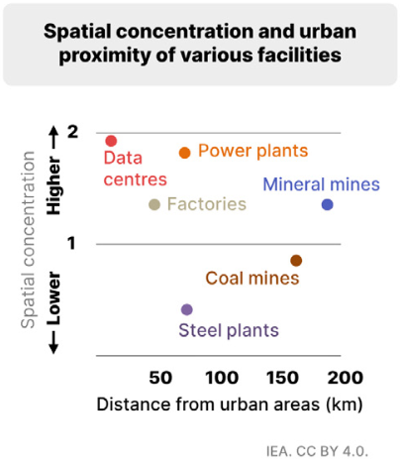
Figure 4: Spatial concentration and urban proximity of various facilities
Data centers are highly concentrated near urban areas. Why? Electrical power loss should be reduced the closer data centers are to power plants. Permitting should be easier the further data centers are from urban areas. Furthermore, according to Table 1, the majority of the data center power today is being used for crypto currency mining. Crypto currency mining does not need to be near urban areas.
One reason for data centers to be near urban areas is to reduce the delay in the data transmission. However, today data can go to foreign countries and back without any human-noticeable delay.
Why else would data centers be located near urban areas? One theory is the feudal theory of the New World Order. This theory implies that the digital control grid will turn the people in urban areas into digitally-controlled slaves. These slaves will be bought and sold by feudal kings / leaders / billionaires. These slavery cities need their own local control grid that can be changed for whatever laws those feudal Lords want to implement.
If anyone has any other logical reasons why data centers need to be near urban areas, please contact us!

Appendix 4– National Security & Keeping Up With China
One reason given for the need to build more data centers in the US is for national security purposes and so that we can ‘keep up’ with China. Two graphics, Figures 5 and 6, from 2024 and 2026 offer slightly different numbers but paint the same picture – the USA has 11x more data centers than China and approximately 45% of the world’s total number of data centers. The argument that we needed data centers for national security and to keep up with China doesn’t make sense.
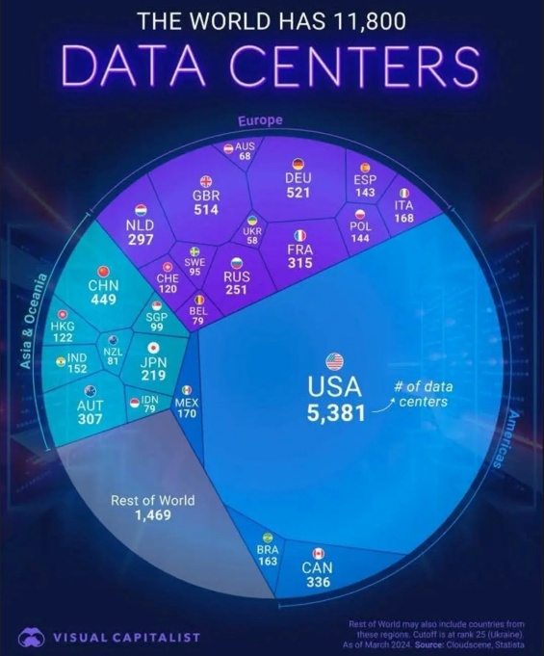
Figure 5: Worldwide number of data centers as of 2024 [50]
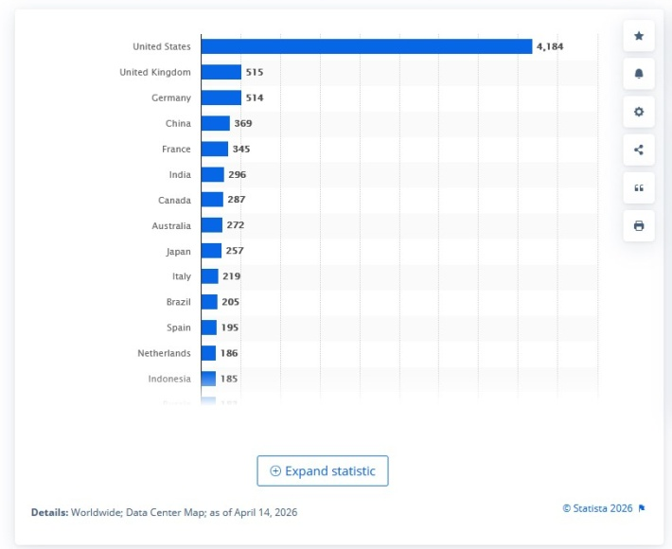
Figure 6: Number of data centers worldwide as of April 14, 2026 [51]

Biographies
Manuel Luschas
Manuel was born, raised, and educated in Germany. He legally immigrated to the US in 2003 and started his career as an electrical engineer in Silicon Valley, CA, working on digital high-speed data communication devices for data centers. The experience gathered over the last 23 years in this field provides him with a valuable background to evaluate and to question the reasons for the recent, seemingly inexplicable push for the digital control grid build out. After escaping the government imposed lockdowns in 2020 in CA by moving to South Dakota, Manuel started a different part-time career as a truck driver, machine operator, and farm hand for an organic grain farm operation. More recently, Manuel decided to invest his time to defend freedom in South Dakota by running for a seat in the State House of Representatives in the Republican Primary election in June 2026. He advanced to the General Election in November. If successful he plans to be a strong voice for freedom in the South Dakota State Capitol.

Susan Luschas
Susan is an MIT-trained PhD in electrical engineering. She worked on some of the first WIFI, Bluetooth, and cell phone chips at startups in Silicon Valley, CA. Upon realizing that her work was building the digital control grid, she transitioned into the energy sector and started working as an adjunct professor at Santa Clara University. In 2020, Susan’s family lost their freedoms in California and moved to Brandon, South Dakota. Susan witnessed big money capture of the government in California, down to the local city council. She realized that the only hope to maintain freedom is through mass non-compliance. Susan has been promoting the use of physical cash in South Dakota for the last several years – one person at a time. She helped get a bill passed in South Dakota in 2025 to require acceptance of cash at school events. Additionally, Susan and her family have been out of the medical system for over a decade. The details of how they do this are on the website Debug Your Health. Since living in South Dakota, Susan and her family still do some engineering, but they spend most of their time farming – organic grains, grassfed beef, chickens, and turkeys.

Contact
Email is the best way to find us: sdacy@alum.mit.edu
If you are not an email person, you can try calling us at: 605-888-8579

Disclaimer
This white paper was prepared by the authors on their own time and their own dime. While this document is believed to contain correct information, we do not assume any legal responsibility for the accuracy, completeness, or usefulness of any information. Reference to any specific commercial products, services, trademarks, manufacturers or otherwise do not necessarily constitute or imply endorsement or recommendation.

Copyright Notice
The authors grant anyone the right to publish, reproduce, or cite this white paper.

Citation
Luschas, M. Luschas, S. “Data Centers: What do we need all this data for?” September 22, 2026, Brandon, South Dakota.

Acknowledgements
Thank you to the South Dakotan who asked Susan the question in February 2026 “How do you know that data centers are for surveillance and control?”
Thank you to all the friends and colleagues who kept nagging us to complete this paper.
Sources
[1]: https://www.demandsage.com/screen-time-statistics/
[2]: https://www.iea.org/commentaries/the-carbon-footprint-of-streaming-video-fact-checking-the-headlines
[3]: https://www.iea.org/data-and-statistics/charts/electricity-per-hour-of-streaming-video-shift-project-compared-to-different-use-cases-2019
[4]: https://techplustrends.com/power-requirements-ai-data-centers/
[5]: https://www.layer3labs.io/guides/how-much-energy-does-ai-use
[6]: https://felloai.com/how-much-energy-does-ai-use/
[7]: https://www.nature.com/articles/d41586-025-00616-z
[8]: https://talkiemate.com/exploring-the-most-popular-questions-people-ask-artificial-intelligence/
[9]: https://thedigitalelevator.com/blog/chatgpt-statistics/
[10]: https://moteventure.com/2026/06/10/the-10-most-common-things-people-ask-ai-right-now/
[11]: https://hbr.org/2026/06/how-people-are-really-using-ai-in-2026
[12]: https://www.youtube.com/watch?v=hS1YqcewH0c
[13]: https://thedigitalelevator.com/blog/chatgpt-statistics/
[14]: Radtke, S. (2017, February 6). Addressing the Data growth challenges in ADAS /AD for simulation and Development. Retrieved from: http://stefanradtke.blogspot.de/2017/02/how-isilon-addresses-multi-petabyte.html
[15]: https://developer.nvidia.com/blog/training-self-driving-vehicles-challenge-scale/
[16]: https://aecc.org/wp-content/uploads/2026/02/AECC_General_Principle_and_Vision_v4.0.6_Feb-26_2026-1.pdf
[17]: https://aecc.org/resources/faq/
[18]: https://aecc.org/wp-content/uploads/2022/10/white-paper-advancing-connected-vehicle-technology.pdf, page 5
[19]: https://seekingalpha.com/news/4635507-waymo-built-a-data-center-on-wheels-to-power-its-driverless-cars
[20]: https://blogs.sw.siemens.com/polarion/the-data-deluge-what-do-we-do-with-the-data-generated-by-avs/
[21]: https://www.nvidia.com/en-us/solutions/autonomous-vehicles/in-vehicle-computing/
[22]: https://www.nvidia.com/en-us/solutions/autonomous-vehicles/#nv-accordion-81eaf7884f-item-ce0da740d3
[23]: https://news.mit.edu/2023/autonomous-vehicles-carbon-emissions-0113
[24]: https://aaafoundation.org/research/american-driving-survey-2024/
[25]: https://blog.vehiclelookup.org/self-driving-car-statistics/
[26]: https://www.consumeraffairs.com/automotive/number-of-drivers-in-us.html
[27]: https://cointelegraph.com/news/bitcoins-fixed-supply-debate-after-blackrock-video
[28]: https://www.coindesk.com/markets/2026/01/23/bitcoin-supply-approaching-20-million-the-final-million-will-take-another-114-years-to-mine
[29]: https://www.iea.org/commentaries/bitcoin-energy-use-mined-the-gap
[30]: https://www.eia.gov/todayinenergy/detail.php?id=61364
[31]: https://cryptoemotions.com/how-long-does-it-take-to-mine-1-bitcoin/
[32]: https://audio.solari.com/crypto_currencies/SolariPapers-4-v3-spreads.pdf, page 6
[33]: https://southdakotasearchlight.com/2026/01/30/sully-county-home-to-sds-largest-data-center-would-welcome-more-with-open-arms-official-says/
[34]: https://eta-publications.lbl.gov/sites/default/files/2024-12/lbnl-2024-united-states-data-center-energy-usage-report_1.pdf
[35]: https://escholarship.org/content/qt33m6w3x0/qt33m6w3x0.pdf?v=lg, page 11
[36]: https://aidatacenterindex.com/countries/united-states/
[37]: https://southdakotadatacenter.org/
[38]: https://www.cleanview.co/data-centers/south-dakota
[39]: https://www.sdpb.org/business-economics/2025-06-16/proposed-leola-data-center-could-improv
[40]: https://www.datacentermap.com/usa/south-dakota/clear-lake/applied-digital-toronto/
[41]: https://www.youtube.com/watch?v=vJYaXy5mmA8
[42]: https://www.technologyreview.com/2025/05/20/1116327/ai-energy-usage-climate-footprint-big-tech/
[43]: https://www.congress.gov/crs_external_products/R/PDF/R48646/R48646.8.pdf
[44]: https://datacenterss.com/data-center-power-planning-calculation-guide/
[45]: https://growers.ag/blog/use-combine-and-monitor-data-to-determine-crop-yield-variability/
[46]: https://farmdocdaily.illinois.edu/2026/04/historical-view-of-us-row-crop-acreage.html
[47]: https://www.weforum.org/stories/health-and-healthcare-systems/four-ways-data-is-improving-healthcare/
[48]: https://www.statista.com/statistics/1107086/total-hospital-number-select-countries-worldwide/
[49]: https://www.iea.org/data-and-statistics/charts/spatial-concentration-of-various-facilities-versus-proximity-to-urban-areas-2024
[50]: https://media.licdn.com/dms/image/v2/D4D22AQE_Q9LBAhNTTg/feedshare-shrink_800/B4DZVgJBK_G4Ag-/0/1741074732432?e=2147483647&v=beta&t=3TVlcH_m5ey-QzW4h7SIWsEqJyp8clvdZYElbq--Pc0
[51]: https://www.statista.com/statistics/1228433/data-centers-worldwide-by-country/

